Thomas Delor - Drummer, composer, arranger
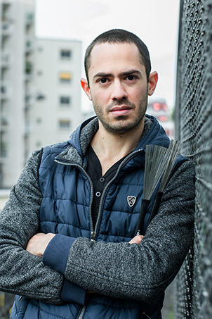
Born in Nice (France) in 1987, Thomas Delor began drumming at the age of 8. He was rapidly drawn toward Jazz, a genre he discovered thanks to his family's record collection and that allowed him to unleash his creativity.
Starting at 16, parallel to his post baccalaureate studies in mathematics, he began performing live with professional musicians in France and Italy. In 2007, he was invited by "Orchestre Classique Instrumental de Nice" conductor Avner Soudry to perform as a guest percussionist.
In 2008, he went to New York City for the first time. This trip gave him the opportunity to network and collaborate with American musicians.
He graduated at the age of 22 and became a mathematics teacher in high schools and French Classes Préparatoires, allowing him to move to Paris in 2010. He quickly established himself in the Parisian Jazz scene and decided to quit his day job as a teacher to fully focus on music.
“Self-taught drummer with a great sense of musicality, famous for his unique, expressive, and individual style, mixing finesse, intensity, sensitivity, and complexity, he bases his work principally on listening, interplay, and a quest for sonority.”
His taste for playing in small bands (from solo to quartet) developed as a means to approach the instrument both rhythmically and diatonically. “The drums are a young instrument that certainly has evolved, but still is in its early stages nonetheless. I would like to break the rule that the drums only functions are rhythm and tempo, as it is taught in France... Nowadays, I believe the drums should be as integral to the melody as any other instrument.”
He won in 2010 the "Jazz à Juan" competition, then the "Golden Jazz Trophy" in 2015 (chaired by Archie Shepp and Jean-Claude Casadesus). In 2016, he is also the winner of the "National Jazz Competition of Nice" and is awarded a prize in the "International Jazz Competition" of Paris (Matmut Music Prize).
From 2016, he is endorsed by the japanese trademark Canopus Drums Company, then in 2019, he signs with the swiss cymbals Paiste.
His musical experience comes from performing at many famous festivals (Jazz in Marciac (Marciac), Sendaï Jazz Festival (Japan), Daegu International Jazz Festival (South Korea), Nice Jazz Festival (Nice), Umbria Jazz Festival (Italy), Agadir International Jazz Festival (Morocco), Jazz à Saint-Germain-des-Prés (Paris), Jazz à Juan (Juan-les-Pins), Orléans Jazz Festival (Orléans), La Baule Jazz Festival (La Baule)…) and Jazz clubs (Sunset-Sunside (Paris), Duc des Lombards (Paris), Ronnie Scott’s Jazz Club (London), Fat Cat Jazz Club (NYC), Cleopatra's Needle (NYC), Blue Note Kyoto, Cotton Club Kofu, Jazz Club Torino, L'Archiduc (Brussels), Bravo (Brussels), Jazz Club de Grenoble, Jazz Club d’Annecy…), as well as touring (New York, Japan, Russia, Morocco, Germany, England, Ireland, Italy, Netherlands, Serbia, Romania, Czech Republic, Poland, France, Switzerland, Belgium…) and teaching workshops in conservatories and schools.
He has collaborated with pianists David Berkman, Eric Lewis, Noah Haidu; guitarists Philippe Petit, Philip Catherine; double bass players Ugonna Okegwo, Miroslav Vitous, Christophe Wallemme; among others. He has recorded several albums.
Apart from the projects he is currently involved with as a sideman (Chamber Metropolitan Trio, Pierre Marcus Quartet, Baptiste Herbin, Philippe Baden Powell, Nuzut Trio…), he is the leader of a trio ("The Swaggerer" in 2018 and "Silence The 13th" in 2020, both praised by the international press, released on the prestigious label Fresh Sound New Talent with the support of SCPP), and has a solo project where all the possibilities of the instrument are on the first place.

